USER GUIDE
D770-D770A
EN

Dear customer,
You have just acquired a new generation Sagemcom telephone.

This device has been manufactured with the utmost care.
If you should have difficulties in operating it, we recommend that you consult this manual or contact the Sagemcom Support Team on 0845 0900 316*.
You can also find information on the following site: www.sagemcomdigital.co.uk
To operate the device safely and easily, please read carefully the paragraph “Recommendations and safety instructions”, page 3.
The CE label confirms that the product complies with the 1999/5/EC regulations of the European Union Parliament regarding wireless systems and telecommunications. The declaration of compliance may be looked up on the www.sagemcom.com website section «Support», or can be obtained from the following address :
Sagemcom Broadband SAS
250, route de l'Empereur 92848
Rueil-Malmaison Cedex - France
Copyright © Sagemcom Broadband SAS
All rights reserved
Sagemcom is a registered trademark
*: 3.95 pence per minute from all fixed lines, tariff cost effective from 01/09/2009
Recommendations and safety instructions 3
Discover 4
Your phone 4
Set-up 6
Connect the base 6
Handset set-up 6
Charging the handset 7
The handset screen 7
Switching the handset on / off 8
Battery replacement 8
Browsing through the menus 9
Menu tree structure 12
Making and receiving calls 14
Managing a call 14
Options during a call 14
Managing several calls 15
Using additional handsets 16
Locating your handset 18
Listening to your messages 18
Locking / Unlocking the keypad 18
Using the phonebook 18
Listening and Recording...(model D770A) 21
Enabling/disabling the answering machine 21
Answering machine message 21
Record a memo 22
Listening to your messages 22
Delete all your messages 23
Setting up 24
The phone 24
The handset 25
The base 27
The line 28
Answering machine settings 28
The alarm 30
Tracing your calls 31
Call logs 31
Environmental information 33
Guarantee 34
Terms and Conditions for United Kingdom & Ireland only 34

Recommendations and safety instructions
For safety reasons, never put the handset in the base station without the battery inserted or without the lid on the battery compartment as this could cause an electric shock. To avoid damaging your handset/base, only use certified rechargeable battery NiMH 2.4 V 600 mAh, never use non-rechargeable battery. Insert the battery in the handset battery compartment.
Only use the power unit supplied and connect it to the electricity mains in accordance with the installation instructions in this user manual and the details on the sticker regarding voltage, electrical current and frequency. As a precaution if there is a risk of danger, the power plug can be pulled out to disconnect the 230 volt power supply. Therefore the sockets should be near the device and easily accessible.
Do not install your DECT telephone in a damp environment, such as a bathroom, washroom, kitchen etc, and not within 1.50 metres of a source of water or outside. This device is designed for use in temperatures of between 5 °C and 40 °C.
Your DECT telephone has a range of approx. 50 metres indoors and up to 300 metres outdoors. The range can be affected by the proximity of metal objects, such as a television and electrical devices.
Zones without reception may appear owing to elements in the building. This can cause brief interruptions in the conversation, caused by faulty transmission.
Certain medical equipment and highly-sensitive machines or security systems may be affected by the transmission power of the telephone. In these cases we recommend adhering to the safety information.
In regions greatly affected by electrical storms we recommend that you protect your telephone circuit with a special fixture for excess voltage.
Your D770A has anti-skid pads that should leave no traces on your furniture and ensure stability.
However, given the wide variety of finishes used by furniture manufacturers, traces may appear on surfaces in contact with the parts of your D770A. Sagemcom Broadband SAS decline all responsibility in any such cases of damage.
Do not attempt to remove screws or open the appliance. It does not contain any user-replaceable parts
Worn out batteries must be disposed of in line with the recycling regulations in this user manual.
This product is intended to be connected to the public analogue telephone network of any British and Irish network operator. Should you experience any problems, contact your nearest specialst dealer or the Sagemcom Support Team on 0845 0900 316.

Recommendations and safety instructions

Discover...

The pack
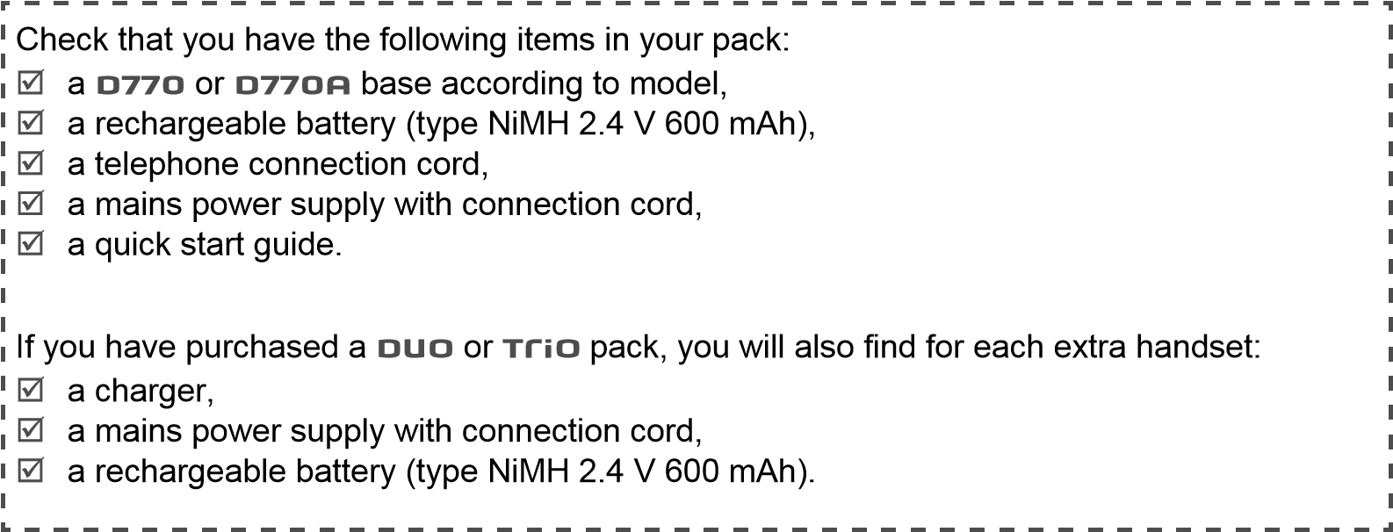

Your phone

The base
Fixed | handset on line.  - or -  answering machine activated
Blinking | New message(s) on your answering machine.  - or -  Accessing the answering machine menu from the handset/remote querying.  - or -  Recording an outgoing message.
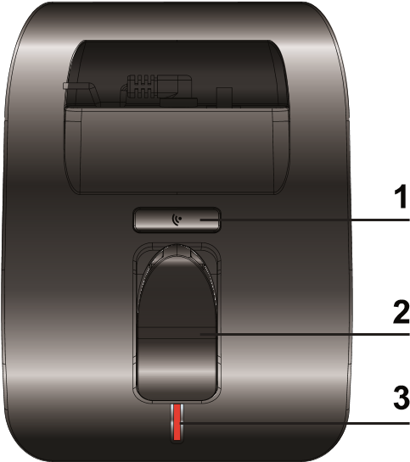
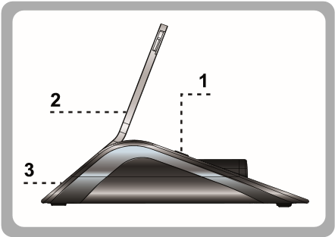
- Handset location.
- Handset(s) Search / Pairing key.
  - Long press: pairing of handsets.
  - Short press: paging of handsets. 3 Indicator light *.
Indicator light operation*:
* Only for D770A
Discover...
1 | Loudspeaker
2 | Graphic screen
3 | Browser
4 | Menu access / validation key: confirm / acces to the menu and/or options
5 | "Hang up" key  - Short press: back to the main menu.  - Short press: end a call (during a call)  - Long press: switch off / switch on the handset
6 | Alphanumeric keypad
7 | "Hash" key:  • Long press : (de)activate the silent mode
8 | Mute button : cuts off the microphone  (during a call)
9 | Microphone
10 | Cancel / Intercom key:  - back to the previous menu  - Correct the entry / Cancel  - Call an additional handset (from the standby screen)
11 | "pick up" key
12 | key 1:  • Long press: access to voicemail service (to set voicemail number, refer to section "Changing your voice mail number ", page 25)
13 | "Star" key"  Long press : (un)lock the keypad
14 | Hands-free key  • enable / disable hands-free mode  (during a call)
15 | R key (flashing, to manage several calls)

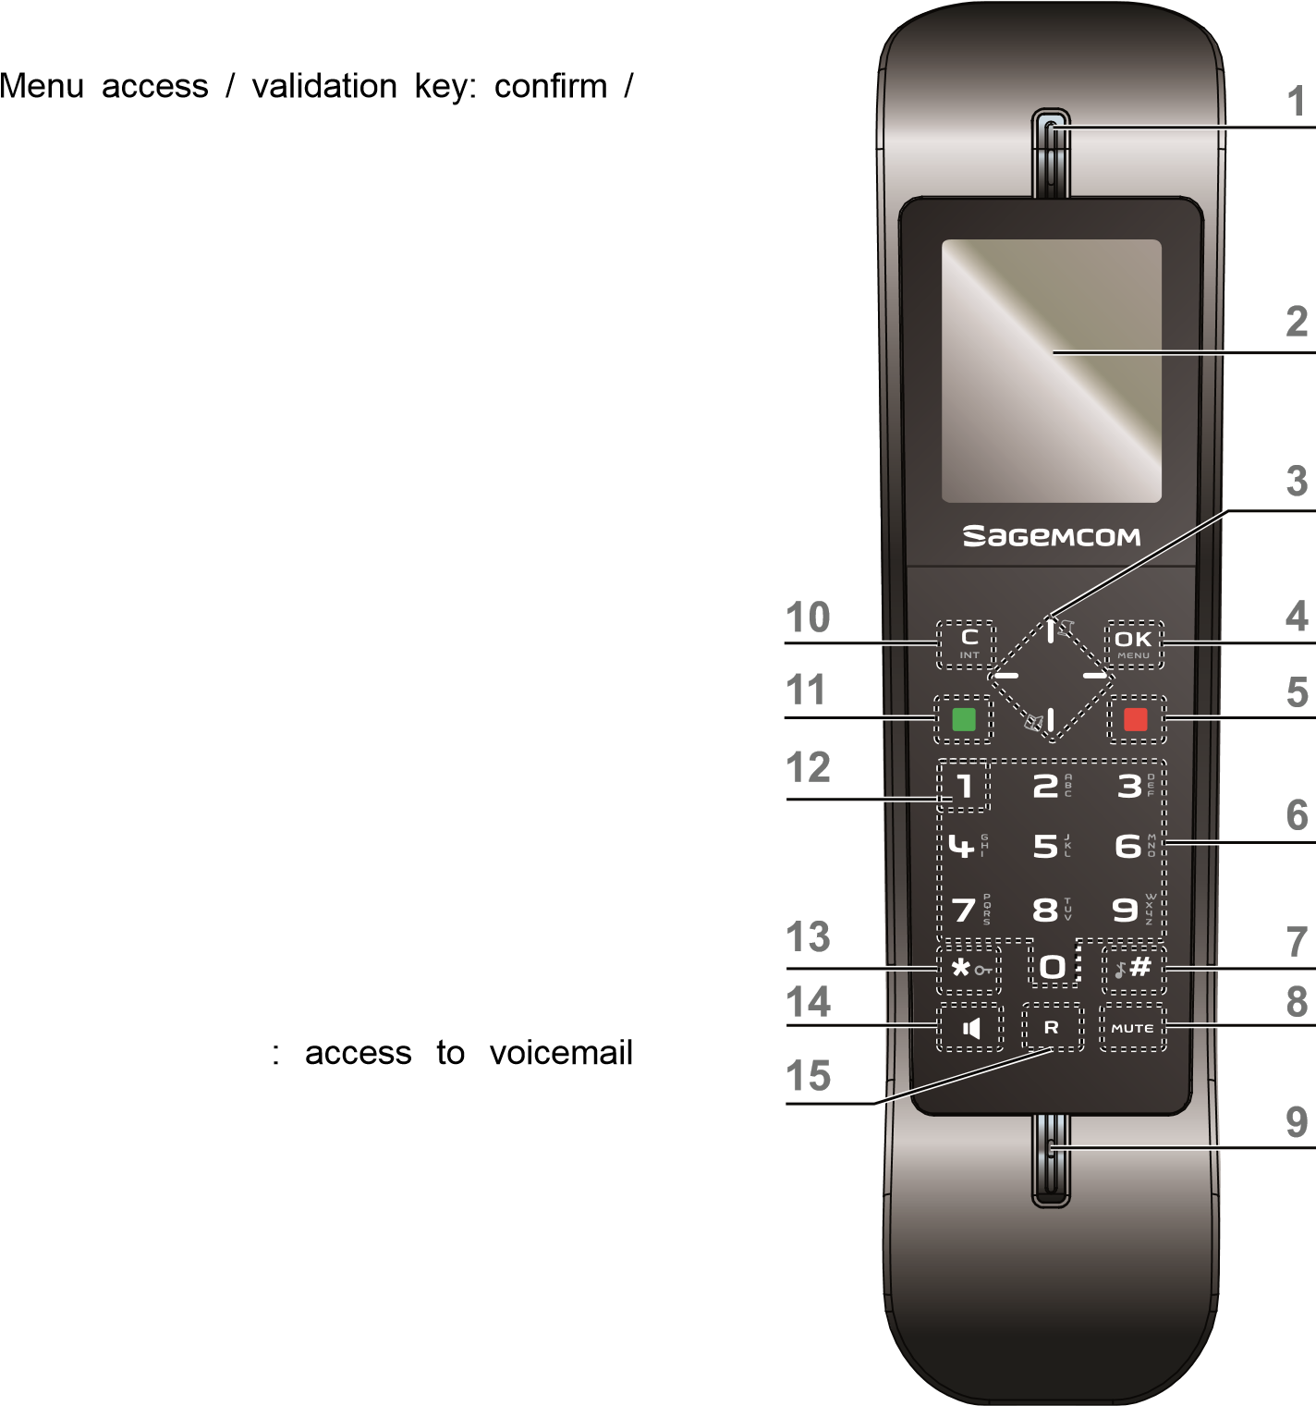
The handset
Discover...

Set-up...

Connect the base
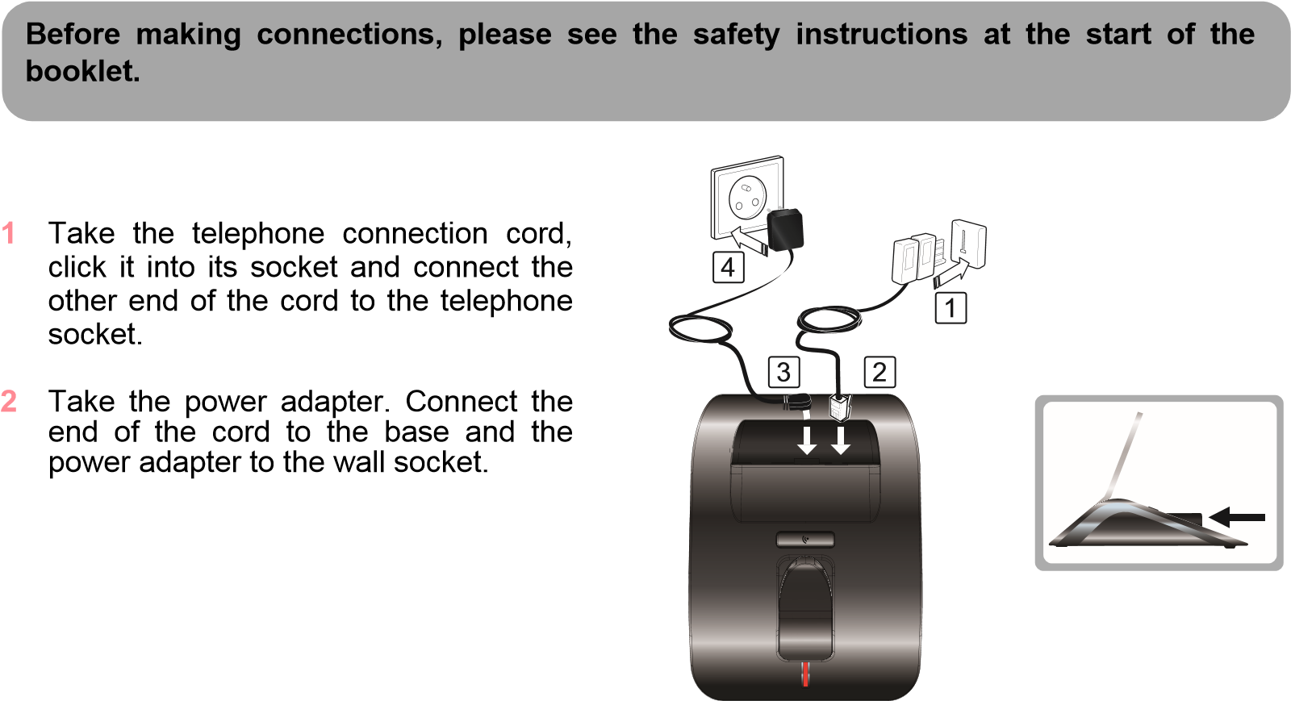

Handset set-up
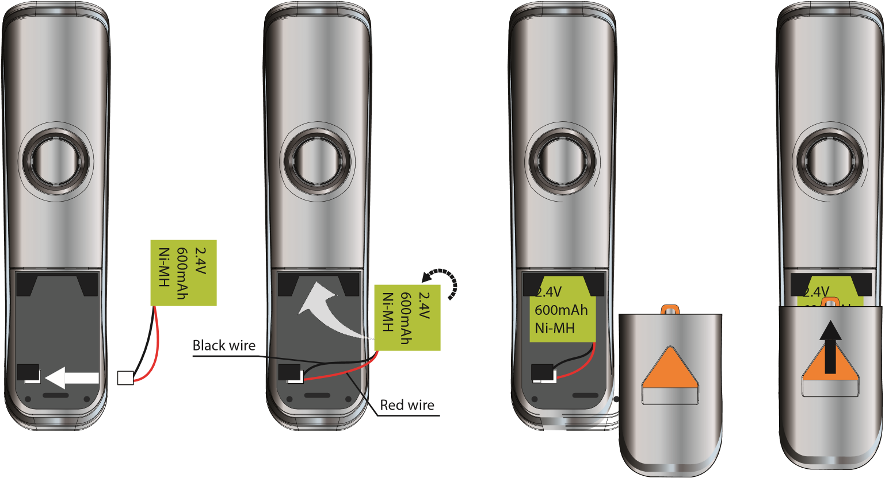
- Take the battery provided in the packaging.
- Insert the connector into its housing complying with the positions of the wires.
- Slide the battery pack into its housing.
- Fit the hatch to the handset.

Charging the handset
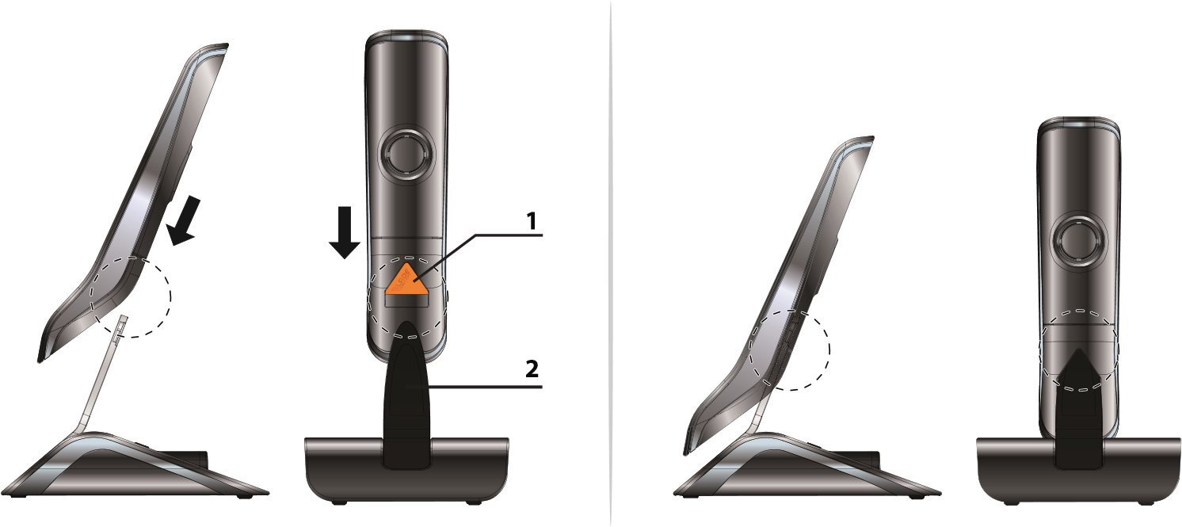
- Gently lower the handset onto the base charging blade. Contacts within the body of the blade ensure electrical contact with the handset.
- Slide the handset downwards.
- Perform a complete battery charging cycle.
The battery charging icon moves to inform you that charging is in progress. The icon display stops moving when the battery is charged.
To ensure optimum charging, leave the handset on the charger for at least 15 hours when using the phone for the first time. During charging, the battery may heat up. This is quite normal and perfectly safe.

The handset screen
In standby mode or during use, your phone screen informs you of your phone’s current state through icons, and in particular:
Interc
Menu
Handset 1
15:29
15
/
12
1
2
3
- Status icons: Indicates your phone’s current state.
- Information field:
  - Standby screen :in the normal state, displays the name of the handset and the current time
  - In the menus: displays the selected menu name, function or setting.
- Action area: displays the actions associated with the multi-function keys and in the ongoing menu
(refer to section "The multifunction keys ", page 9).
THE ICONS DISPLAYED
 | DECT signal |  | Keypad locked
 | New missed call(s) |  | Silent mode activated
 | Answering machine activated |  | Battery charge condition
 | New message(s) on your  answering machine |  | Speakerphone enabled
 | New message(s) on your  answering voicemail |  | Phone in conversation mode
 | Alarm on

Switching the handset on / off
To switch on the handset, give a long press on the key .
To switch off the handset, give a long press on the key .
The message Switch off Handset? is displayed.
Press the key to confirm.

Battery replacement
- Turn off the handset. Turn it over to access the battery compartment hatch.
- Remove the battery compartment hatch.
- Remove the old battery, Insert the connector into its housing complying with the positions of the wires.
- Refit the battery compartment hatch.
Worn out batteries should be discarded in accordance with the recycling instructions given in chapter “Environmental information”, page 33.
To prevent damage to your handset, only use approved rechargeable batteries NiMH 2.4 V 600 mAh. Never use non-rechargeable batteries.

Browsing through the menus

Browser
To access the phone menu, press .
When choosing menus, press the top  or the bottom  the left  the right  of the browser.
In the option list, press the top  or the bottom  of the browser.
From the standby screen:
Access to the outgoing call list
In a menu:
Navigate up (

)
From the standby screen:
No action
In a menu:
Navigate right (

)
From the standby screen:
Access to the caller list
In a menu:
Navigate left (

)
From the standby screen:
Access phonebook
In a menu:
Navigate bottom (

)

The multifunction keys
Your telephone has two "multifunction" keys which you can use in several ways:

or

 | From the standby screen | In a menu
 | To access the telephone menu. | To enter a menu, to validate an action in a menu.
 | To make an Intercom call (call to another handset). | To return to the previous menu. To delete characters. With each press, the character preceding the cursor is deleted.
Main menu
Back
Phonebook
OK
Display
Phonebook
Audio
Alarm X
Answer Machine
Settings

Illustration
To browse-through menus, use the browser and two multifunction buttons:
- Press the key . The main menu is displayed on the screen.
- Press the top  or bottom  or the left  or the right  of the browser to scroll through the menus and access the desired menu.
- Confirm your choice by pressing the key .
- Press the top  or bottom  to scroll through the menus and access the desired function.
- Confirm your choice by pressing the key .
- Cancel your choice / Exit the displayed menu :
  - either by pressing the key .
  - or by pressing the red key ; the home screen is displayed.

Detailed browser example: adjust the date and time
ADJUST THE DATE AND TIME
It is recommended to set the date and time accurately to allow you to keep track of the timings of your calls and messages.
If you have the Display number option, the date and time will, depending on your operator, be set automatically when you receive a call.
To access the date and time setting menu:
- Press the key . The main menu is displayed on the screen.
- Select Settings menu by pressing the top  or bottom  or the left  or the right  of the browser. Confirm your choice by pressing the key .
- Scroll through the menus to the Date & Time menu by pressing the top or bottom of the browser. Confirm your choice by pressing the key .
- Scroll through the menus to the Set Time/Date menu by pressing the top or bottom of the browser. Confirm your choice by pressing the key .
- Enter the time: using the numeric keypad (hours then minutes). Confirm your entry by pressing the key .
- Enter the date using the numeric keypad (day, month and year) in the form DD/MM/YYYY. 7 Confirm your entry by pressing the key .
You have just set your phone’s current date and time. You can also set the date and time display format (see “Setting the date and the time format”, page 25).
Refer to the “Menu tree structure”, page 12 section to find out about your phone’s functions.

Procedures in your booklet
The procedures in your booklet are presented in the form of sheets.
To facilitate their implementation, each of them includes the following as appropriate:
- the keys associated to directly access the function described, and/or
- the path for accessing the function described in the menu.
EXAMPLE : TO (DE)ACTIVATE THE SILENT MODE
means you can use the key(s) offered to access the
(Long press) function. means you can access this function by displaying the
Go to the menu Audio > Ring Tone menu, then going down the menus displayed to the
Setup > Volume > Off function Volume and selecting the state Off.

Menu tree structure
Phonebook New Entry
 | Option | Calling Number
 |  | Edit Entry
 |  | View Entry
 |  | Copy Entry * | * You must have at least two handsets paired on the same base. 
 |  | Copy All * | Refer to section “Associating a new handset”, page 26.
 |  | Delete Entry
 |  | Delete All
 |  | Capacity
 |  | Edit Call Group
 |  | Speed Dial
Audio Ring Tone Setup External Calls
Internal Calls
Volume
Silent
Signal Tones
Display Handset Name
Screensaver
Contrast
Settings
Time Format
Date & Time
Date Format
Set Time/Date
Display
Select Base
Handset
Language
Auto Answer
Register HS
De-register
Reset Handset
Flash Time
Base
Dial Mode
Call Sharing
Change PIN
Reset Base
Mailbox

Menu tree structure
Alarm | Alarm X * | Alarm On/Off | * : X 1 to 5
 |  | Time
 |  | Melody
Answer Machine
**
Play Messages
** : model
D770A
Delete Old Msgs
Answer On/Off
Greeting Msg.
Record memo
Settings
**
Answer Mode
TAM Language
Answer Delay
Recording Time
Remote Access
Menu tree structure

Making and receiving calls...

Managing a call

Making a call
FROM THE HANDSET - METHOD 1
- Dial your contact’s number.  
If you make a mistake, press the key to delete the last character entered.
- Press the key .
FROM THE HANDSET - METHOD 2
- Press the key .
- Dial your contact's number. A beep sounds.
At the end of the call, press the handset key and replace the handset on its base. Receiving a call
- Press the key to take the call.
- At the end of the call, press the handset key and replace the handset on its base.
A beep sounds.
Your handset includes an Auto Answer. function. For further details, refer to the “Answering automatically”, page 26.

Options during a call
You can use the following options during a call:

Enable/Disable loudspeaker (speakerphone mode)
During a call press
.
The icon
appears on the handset screen.
Adjusting the volume
H
ANDSET

LOUDSPEAKER
When the battery charge icon is at minimum, the hands-free function is not available
until the next charging cycle.
FROM THE HANDSET
- To increase the volume, press in the browser.
- To decrease the volume, press in the browser .

Enabling/Disabling the secret mode
The secret mode allows you to temporarily mute the line so that you are not heard by the caller.
During a call press mute.
The icon appears on the handset screen.

Managing several calls
Your phone allows you to take and manage several calls when you are already on the line (depending on your line provider). These calls can be managed with the key . Receiving a second call
During a call, a beep indicates the arrival of a second call.
To take this call, press the key then the key .
Your first call is put on hold and you can talk with the second caller.

Making a second call
During a call, press the key then dial your contact’s number.

Switching from one call to the other
Press the key then the key to switch from one call to the other.
The call in progress is then put on hold and you can take back the previous call.

Ending one of the calls in progress
Press the key then the key to end the current call. You will return to the other call.

Talking with two contacts at the same time (3-way conference)
Press the key followed by the key .
You can then talk with your two contacts at the same time.
To end the 3-way conference, press the key .

Using additional handsets
You can associate additional handsets with your phone: You can then make and receive outside calls or calls between these handsets.
You first have to pair the handsets with the base.
For further details, refer to the “Associating a new handset”, page 26 .
Calling another handset (intercom) Press the key .
If you only have two paired handsets on the same base: The handset called rings automatically. Simply take the call.
If you have more than two paired handsets on the same base:
- Press the key . Select the handset with the or key.
- Press the key . The selected handset rings. 3 Take the call from the called handset.
4 End the call by pressing .

Join in a conversation already taking place
You must have at least two handsets paired on the same base.
If the share call mode is activated, you can join in a conversation from another handset registered with the same base (refer to paragraphe “Authorising/prohibiting listening in”, page 25).
From another handset (registered on the same base), press the green key .
You will then join in the conversation

Transferring a call to another handset
During a call press
key.
You must have at least two handsets paired on the same base.
If you only have two paired handsets on the same base: The call is transferred directly to the second handset.
- Simply take the call on the second handset.
- Hang up the call on the first handset with the key.
To cancel the transfer before hanging up the second handset, press the key.
If you have more than two paired handsets on the same base:
- Select the handset to which you want to transfer the call using the or key.
- Press the key . The handset called rings.
- Pick up the other handset and then transfer the call by pressing .

Switch between the outside call and the intercom call
During a call press
key.
You must have at least two handsets paired on the same base.
If you only have two paired handsets on the same base: The call is transferred directly to the second handset.
- Simply take the call on the second handset. Your contact is put on hold.
- Use key to switch betwin calls.  
The handsets display the message On Hold.
If you have more than two paired handsets on the same base:
- Select the handset to which you want to transfer the call using the or key.
- Press the key . The handset called rings.
- Simply take the call on the second handset. Your contact is put on hold.
- Use key to switch betwin calls. The handsets display the message On Hold. 3-way conference
During a call, you can have a second person in your home take part by activating the call on the second handset. To do this, you must have paired both handsets to the base.
1
During the call, press the
key.
2
If necessary select the desired handset with the or key.
 
You must have at least two handsets paired on the same base.
The selected handset will ring. Your contact is put on hold. 3 Simply take the call on the second handset. 4 On the first handset, press the key.
You can then all talk to each other. The handsets display the message Conference.
The activation of 3-way conference is possible only when you are in conversation with the internal handset call.

Locating your handset
If you have misplaced your handset, press the key on the base. The handset rings.

Listening to your messages
If you have a voice mail service with your line provider, press and hold key or dial the number given by your line provider directly.
Follow the instructions given by your line provider to listen to and manage your messages.
appears on the handset screen when you have at least one new message.
The icon
To modify the number please refer to
“
Changing your voice mail number
”, page

25
.

Locking / Unlocking the keypad
You can lock the keypad when you are not making a call.
Give a long press on the key to lock and unlock the keypad.
The message Keypad Locked and the icon appears on the handset screen when the keypad is locked.

Using the phonebook

Create an entry
- Go to the menu Phonebook.  
The directory opens.  
If there are no entries, the message List Empty is displayed.
- Press the key .
- Select New Entry with the or key and press .
- Specify the required information by confirming at each step with :
  - Name: enter your contact’s name,
  - Number: enter their number,
  - Group: if necessary, select the group in which to include the contact with the or key. Call the contact from their entry
- Go to the menu Phonebook.
- Select the contact to call with the or key.
- Press the key .
- Select the option Calling Number and press .
You can also press the key to call the contact selected in the directory directly.

Search for an entry
- Go to the menu Phonebook.
- Enter the first letter of the name.

Changing an entry
- Go to the menu Phonebook.
- Select the entry to be modified with the or key.
.
- Press the key .
- Select the option Edit Entry and press
- Use the key to delete characters one by one.
1
6
.
Change the name and/or number type and confirm with
Deleting an entry
Go to the menu
Phonebook
.
Select the entry to be deleted with the or key.
.
Press the key
.
5
Confirm the deletion by pressing the
key.
Checking available directory space
The action
Delete Entry
deletes the selected entry.
 
The action
Delete All
deletes all the entries in the directory.
2
3
4 Select the option Delete Entry and press
- Go to the menu Phonebook.
- Press the key .
- Select the option Capacity and press .
- The number of existing entries is displayed with the total possible number (2/100).

Associating a speed dial number with an entry
Speed dial allows you to associate a numeric key with an entry in your directory.
Once you have made the association, you can dial your contact's number automatically by long press on the associated key.
- Go to the menu Phonebook.
- Press the key .
- Select the option Speed Dial and press .
- Select with or the numeric key of your choice and press .
- Select the desired contact with or and press .

Transferring entries from one handset to another
You must have at least two handsets paired on the same base.
Each handset has its own phonebook.  
To transfer one or more entries from a phonebook to another handset:
- Go to the menu Phonebook.
- Press the key .
- Select the desired option and press .
  - Copy Entry: to transfer the current entry.
  - Copy All: to transfer all the directory entries.
- Select the handset to which the data are to be transferred. 
The receiving handset rings and displays the message Transfer Phonebook ?.
- Accept the transfer on the destination handset by pressing the key .

Listening and Recording...(model D770A)
Answering your phone has two reception modes:
- Answer Only : a message indicates that you are not available. Your caller cannot leave any messages.
- Answ & Record : a message tells your caller that they can leave a message.
Your answering machine has a capacity of 18 minutes (3 minutes for the OGM and 15 minutes for the messages).
When your answering machine reaches its maximum recording capacity, the answering machine switches to "Answer Only" mode automatically, the icon flashes on the screen and the message " Message Full ! " is displayed. You have to delete some (or all) of your messages to free memory space.

Enabling/disabling the answering machine
- Go to the menu Answer Machine > Answer On/Off.
- Select the desired state, On or Off, and validate with .

Answering machine message
If you have not saved a personal announcement, the answering machine will automatically use the pre-recorded announcement.

Recording your outgoing message
1 Go to the menu Answer Machine > Greeting Msg. > Record OGM > Answ & Record (or Answer Only).
2
Clearly state your announcement then press
to stop recording.
 
The recorded announcement is played.
The maximum recording duration for an announcement is 180 seconds.

Listening to your outgoing message
- Go to the menu Answer Machine > Greeting Msg. > Play OGM > Answ & Record (or Answer Only).
- The currently used announcement is played.

Erasing your outgoing message
- Go to the menu Answer Machine > Greeting Msg. > Play OGM > Answ & Record (or Answer Only).
- The currently used announcement is played.
- During the playback of the personal announcement used, press .

Record a memo
With this function you can leave a personal message on your answer machine. Until it has been listened to, it will be considered as a new message.
- Go to the menu Answer Machine > Record memo.
- Clearly state your message then press to stop recording.  The recorded message is played.

Listening to your messages
If you have received new messages, the icon appears on the screen of the handset and the base indicator light flashes *.
- Go to the menu Answer Machine > Play Messages.
- When playing back messages, use the following keys:
key | Action | key | Action
2 | Delete the current message | 5 | Stop playing the messages
4 | - 1 press: replay the current message  - 2 presses: play the previous message | 6 | Play the next message
The messages are played back in chronological order (from the oldest messages to the most recent messages).
At the end of the last message, the playback will stop automatically.
* Only for D770A model

Querying your answering machine remotely
This function allows you to check your messages from a remote phone.
To modify the remote enquiry code, refer to paragraph “
Modify the remote enquiry
code
”, page 29.
- Dial your phone number.
- While listening to your message press the * key and enter your remote access code.
- You can perform the following operations :
Key | Action | Key | Action
4 | Play the previous message | 2 | Delete the message being played
5 | Play messages | 9 | Disable the answering machine
6 | Play the next message | 7 | Enable the answering machine
8 | Stop playing messages

Delete all your messages
- Go to the menu Answer Machine > Delete Old Msgs.
- Press key to confirm.

Setting up...

The phone

Changing the ringing tone
- Go to the menu Audio > Ring Tone Setup > External Calls or Internal Calls.
- You can change the ringing tone of:
  - outside calls,
  - calls between handsets (intercom).
- Scroll through the pre-recorded ring tones and confirm with .

Modifying the ringing volume
- Go to the menu Audio > Ring Tone Setup > Volume.
- Select the sound level and validate with .

Enabling/Disabling the silent mode
- Go to the menu Audio > Ring Tone Setup > Volume.
- Select the option Off and validate with .
The icon appear on the handset screen when the silent mode is active.
You can also activate / deactivate the silent mode by a long press on the key.

Activate/deactivate beep call *
- Go to the menu Audio > Ring Tone Setup > Silent.
- Select the status:
  - Beep : When receiving a call, a beep is emitted by the handset.
  - Off : No beep is emitted when receiving a call.
- Confirm with .
* ON when silent mode is active.

Enabling/Disabling audio alerts
- Go to the menu Audio > Signal Tones.
- The audio alerts apply to:
  - Key Tone: keypad keys pressed,
  - Confirm Tone: confirming a menu,
  - Low Battery: low battery,
  - Out of Range: loss of signal between the base and the handset.
- Select the desired state, On or Off, and validate with .

Authorising/prohibiting listening in
The intrusion function authorises or prevents a second handset registered on the same base from joining in a current conversation.
- Go to the menu Settings > Base > Call Sharing.
- Select "On" or "Off" and validate with .

Setting the date and the time format
- Go to the menu Settings > Date & Time > Time Format and Date Format.
- You can set:
  - Select the desired Time Format: 24-Hour or 12-Hour.
  - Select the desired Date Format: DD.MM.YYYY (day, month, year) or MM.DD.YYYY (month, day, year).

Setting the date and the time
- Go to the menu Settings > Date & Time > Set Time/Date.
- Enter the hour in starting with the hours and then the minutes and confirm with .
- Enter the date and confirm with . Changing your voice mail number
- Go to the menu Settings > Mailbox.
- Enter the voice mail number and validate with .

The handset

Adjusting the contrast
- Go to the menu Display > Contrast.
- Select the desired level of contrast and validate with . Personalising the name of a handset
You can personalise the name of your handset.
- Go to the menu Display > Handset Name.
- Enter the desired name and validate with .

Enabling/Disabling the screen saver
This function displays a clock moving around regularly after 30 seconds of inactivity.
- Go to the menu Display > Screensaver.
- Select the desired state, On or Off, and validate with .

Changing the display language
- Go to the menu Settings > Handset > Language.
- Select the language to be used and validate with .

Define the priority base for a handset
This function allows you to specify the priority base to be used for making calls.
1
Go to the menu
Settings
>
Handset
>
Select Base
.
2
Select the base that the handset should use first and validate with
.
Only if you have paired the same handset on several bases.

Answering automatically
With this function you can answer a call simply by lifting the handset from the base.
- Go to the menu Settings > Handset > Auto Answer.
- Select the desired state, On or Off, and validate with .

Associating a new handset
Your phone allows you to associate other handsets with the base. You then have to pair them so that they are recognized.
FROM THE BASE:
1 Enable the base pairing mode: Presse and hold button.
FROM THE HANDSET:
- Go to the menu Settings > Handset > Register HS.
- Enable the handset pairing mode.
- Enter the base code if necessary (by default 0000).
The default code is 0000.
Once the handset is registered, the pairing mode is automatically exited.

Removing a handset registered on the base
- Go to the menu Settings > Handset > De-register.
- Enter the base code and validate with 3 Select the handset to unpair from the base and validate with .
.
The default code is 0000.

Resetting the handset
When you reset your handset, all the settings are returned to their initial values (factory settings), except for the phonebook.
- Go to the menu Settings > Handset > Reset Handset.
- Enter the base code and validate with .
- Press to confirm.

The base

Enabling the pairing mode
You enable the pairing mode when you associate an additional handset.
Give a long press on the key on the base.
The base indicator light flashes *: the base is in pairing mode.
* D770A only
Your base will remain in pairing mode for about 1 minute.

Changing the default code
- Go to the menu Settings > Base > Change PIN.
- Enter the current code and validate with .
.
- Enter the new code and validate with
- Re-enter the new code and validate with .

Resetting the base
When you reset your base, all the settings are returned to their initial values (factory settings), except for the phonebook.
- Go to the menu Settings > Base > Reset Base.
- Enter the base code and validate with .
- Press to confirm.

The line
We do not recommend that you change line settings without first contacting your line provider, as this may result in your phone line being disconnected.

Changing the dialling type
You can use a voice frequency [Tone] or pulse [Pulse] based dialling system .
- Go to the menu Settings > Base > Dial Mode.
- Select the desired system and validate with .

Changing the flash duration
You can configure the flash duration if you use your phone abroad or on a private network.
- Go to the menu Settings > Base > Flash Time.
- Select the desired value and validate with .

Answering machine settings

Anrufbeantworter – Modus ändern
The answering machine of your phone has two reception modes:
- Answer Only : a message indicates that you are not available. Your caller cannot leave any messages.
- Answ & Record : a message tells your caller that they can leave a message.
- Go to the menu Answer Machine > Settings > Answer Mode.
- Select the desired mode and validate with .

Modify the answering machine language
The announcements will be played back in the language you select.
- Go to the menu Answer Machine > Settings > TAM Language.
- Select the desired language and validate with .

Changing the number of rings
This parameter enables you to set the number of times your telephone rings before the answering machine answers a call. The number of rings can be set between 2 and 8.
You can also select the "Time saver" mode.
The "Time saver" mode automatically determines the number of rings: If there are no new messages on the answering machine, the number of rings will be 4, otherwise the number of rings will be 2.
- Go to the menu Answer Machine > Settings > Answer Delay.
- Select the desired number of rings and validate with .

Change the message recording duration
- Go to the menu Answer Machine > Settings > Recording Time.
- Select the desired duration and validate with .

Modify the remote enquiry code
You can give this code to anyone who can read the messages from a remote phone.
To secure the remote access to your answering machine, it is strongly recommended to change the remote access code (0000 by default).
- Go to the menu Answer Machine > Settings > Remote Access > On.
- Enter the remote enquiry code (0000 by default) and validate with .
.
.
- Enter the new remote enquiry code and validate with
- Re-enter the new remote enquiry code and validate with

The alarm
The alarm sounds through the handset speaker.
To stop the alarm clock, press any key on the handset.

Finding out the alarm status
When the icon is displayed on the handset screen the alarm is activated.

Enabling / Disabling the alarm
- Go to the menu Alarm > Alarm X * > Alarm On/Off *.
- Select the desired state, On or Off, and validate with .
Once the alarm is enabled, the icon is displayed on the screen.

Defining the wake-up time
1
Go to the menu
Alarm
>
Alarm X
* >
Time
.
2
Enter the desired time and validate with
.
When the 12-hour time format is set, use the
key to switch between AM
(
before 12 o'clock) and PM (after 12 o'clock
).
- Select the desired repetition frequency:
  - Once: a single time on the same day or on the following day at the set time.
  - Daily: every day at the set time.
  - Mon to Fri : Monday to Friday.
  - Mon to Sat : Monday to Saturday.
  - Sat to Sun : Saturday and Sunday only.
- Validate with .
* : X alarm number 1 to 5.

Changing the alarm ringing tone
- Go to the menu Alarm > Alarm X * > Melody.
- Scroll down the list of available ring tones and confirm with .
* : X alarm number 1 to 5.
The alarm

Tracing your calls...

Call logs
Logs are lists of numbers or events received by your phone.
Depending on your line provider, call logs contain the following information :
• your contact’s name or number, • the call time or date.

Viewing the received call log
- Press  key.
- Scroll through the list of stored numbers. Missed calls are preceded by a black dot.
You can use the options described in section “Managing incoming or outgoing calls”, page 31. Viewing the dialled call log
- Press () key.
- Scroll through the list of stored numbers.
You can use the options described in section “Managing incoming or outgoing calls”, page 31.

Managing incoming or outgoing calls
Use the following options from the call list to:
- Details: display the information about the selected call,
- Delete Entry: delete the selected log entry, • Delete All: delete all the numbers in the list.
- Calling Number: call the displayed number,
- Save Number: save the number in your phonebook,

Configuring the incoming calls log
CALL DISPLAY
This function allows you to define the type of calls to be displayed in the incoming call log.
- All Calls,
- Missed Calls only.
- Press key.
- Press .
- Select Settings then press
- Select Call List Type then press .
.
- Select the type of call to display in the incoming call log .
Tracing your calls...
NOTIFICATION OF MISSED CALLS
This function allows you to enable or disable the icon notifiaction of missed call(s) .
- Press key.
- Press .
- Select Settings then press
- Select New Call Alert then press .
.
.
- Select On or Off then press
Tracing your calls...

Environmental information
Environmental protection and sustainable development is an important priority for Sagemcom. Sagemcom has a policy of using environmentally- friendly systems and makes environmental protection an essential part of the life-cycle of its products – from manufacturing, to installation, operation and disposal.

Packaging
The logo (green point) on the packaging means that a fee is paid to an authorised national organisation to improve packaging recycling and the recycling infrastructure. Follow the local sorting regulations for this type of waste product in order to improve recycling.
Batteries
If your product contains batteries, they must be disposed of at the designated collection points.

The product
The crossed out dustbin displayed on the product signifies that it belongs to the electrical and electronic equipment group. The European regulations request you to carry out your own selective recycling collection at:
- the sales outlet when you buy a similar new device.
- the collection points available in your area (recycling centres, sorting points, etc).
This means you participate in the recycling and valorisation of used electric and electronic goods which would otherwise have a negative impact on the environment and health.
Environmental information

Guarantee

Terms and Conditions for United Kingdom & Ireland only
In order to apply the guarantee, or for technical assistance, you should contact the Sagemcom Helpdesk (0845 0900 316) or the retailer you purchased your equipment from.
Please make sure that you use your equipment only for the purpose for which it was designed and under normal usage conditions.
Sagemcom do not accept any liability for the equipment if used outside the frame of its original designed purpose or any consequence that may arise from this usage.
Should any malfunction arise, the Sagemcom Helpdesk or your retailer will advise you how to proceed.
A) General Guarantee conditions
Sagemcom undertakes to remedy by repair or exchange at its own convenience, free of charge for labour and replacement parts, any defects in the equipment during the guarantee period of 12 (twelve) months or 3 (three) months for accessories, from the date of original invoice of the Equipment, where those defects are a result of faulty workmanship.
Unless the customer has concluded with Sagemcom a maintenance contract in respect of the equipment which specifically provides for repairs to be carried out at the customer`s premises, the repairs will not be carried out on the equipment at the customer premises.
The customer must however return the defective equipment at his/her own expense, to the address supplied by the Sagemcom Helpdesk or by the retailer.
In the case that a product needs to be sent in for a repair, it must always be accompanied by a proof of purchase (which is not altered, written on or in any way made illegible) showing that the product is still under guarantee. In the case that no proof of purchase is enclosed, the Sagemcom repair centre will use the production date as its reference for establishing the guarantee status of the product.
Apart from all legal obligatory rules, Sagemcom, do not give any Guarantee, either implicit or explicit which is not set force in the present section, and can not be held responsible for any direct or indirect, material or immaterial damage, either in or out of the frame of the present guarantee. If any provision of this guarantee shall be held to be in whole or in part invalid or illegal due to an obligatory rule applicable to consumers pursuant to their national legislation, such invalidity or illegality shall not impair or affect the remaining provisions or parts of this guarantee. This guarantee does not affect the Customer statutory rights.
B) General Guarantee conditions
Sagemcom shall have no liability under the guarantee in respect of:
• Damage, defects, breakdown or malfunction due to one or more of the following:
- Failure to properly follow the installation process and instructions for use
- An external cause to the equipment (including but not limited to: lightening, fire, shock, vandalism, inappropriate conditions of electrical network or water damage of any nature)
- Modifications made without the written approval of Sagemcom
- Unsuitable operating conditions, particularly of temperature and humidity - Repair or maintenance of the equipment by persons not authorised by Sagemcom

Guarantee
- Wear and tear from normal daily use of the equipment and its accessories
- Damage due to insufficient or bad packaging of equipment when returned to Sagemcom
- Usage of new versions of software without the previous approval of Sagemcom
- Work on any equipment or software modified or added without the prior written consent of
Sagemcom
- Malfunctions not resulting from the Equipment or from software installed in user workstations for the purpose of use of the equipment. 
Communication problems related to an unsuitable environment including:
- Problems related to access and/or connection to the Internet such as interruptions by access networks or malfunction of the line used by the subscriber or his correspondent
- Transmission faults (for example poor geographical coverage by radio and TV transmitters, interference or poor line quality)
- Local network faults (wiring, servers, workstations) or the failure of the transmission network (such as but not limited to interferences, fault or poor quality of the network)
- Modification of the parameters of the cellular or broadcast network carried out after the sale of the Product
• Normal servicing (as defined in the user guide supplied with the equipment) as well as malfunctioning due to servicing not being carried out. Servicing costs are in any event always borne by the customer.
Malfunctions resulting from the usage of products, consumables or accessories not compatible with the equipment.
C) Out of Guarantee Repairs
In the cases set forth in B) as well as after expiry of the guarantee period, the customer must ask the Authorised Sagemcom Repair Centre for a cost estimation prior to work being carried out. In such cases, the repair and delivery costs will be invoiced to the customer.
The foregoing shall apply unless otherwise agreed in writing with the customer and only for the United Kingdom and Ireland.

Guarantee

Sagemcom Broadband SAS
250, route de l'Empereur
92848 Rueil-Malmaison Cedex - France
All rights reserved. The information and specifications included are subject to change without prior notice. Sagemcom Broadband
SAS tries to ensure that all information in this document is correct, but
does not accept liability for error or omission. Non contractual
document. All trademarks are registered by their respective ow
ners. Simplified joint stock company - Capital 35 703 000 € - 518 250 360 RCS
NANTERRE.
253566060
A
Tel. +33(0)1 57 61 10 00 - Fax : +33(0)1 57 61 10 01
www.sagemcom.com

